Did You Know that Jan, Sue, Karen and Dallas attended The Grand Board meeting last week? Their purpose was to share the colors we are planning on painting our buildings. You are welcome to watch the meeting on Zoom.
Did You Know that the new sign saying you are entering The Grand is being built across the street? Check it out!! We can now say that we feel that we are a part of The Grand.
Did You Know that the concrete benches located in buildings one and two will be relocated? Some of them will be finding a new home on the La Solana grounds.
Did You Know that we will soon have three regular email blasts? 1. Did You Know by Jan and Patti, 2. Painting Project Update by Karen and Patti and 3. Did You Ever Wonder, (which will review our R&R and Architectural requirements) by Greg, Sue and Debbie. Keep an eye out and stay up to date on the happenings here at La Solana.
Did You Know that the LRP Committee has finished the focus groups and will soon be presenting all the ideas and goals to the Board? Thank you to Jean McBrien for chairing. This is so exciting as it started with the Survey you filled out and after a lot of work your opinions and ideas will be turned into goals for the future of our community.
Did You Know that Debbie is working on the Calendar? Debbie will be entering in all activities including the Social Committee events on the calendar. Becky & Patricia have been giving some great suggestions for the upcoming summer events. So, stay tuned for what’s coming up!
The Social Committee has done a superb job this season with a variety of themes: The All-People Birthday Party, Take Me Out To The Ball Game, Soup Dinner, Baked Potato Party and so many more outstanding events. Hats Off Ladies!!
Did You Know that this Wednesday we will have painting contractors in the community? They will be doing a walk around and hopefully will submit bids for our painting project.
Did You Know that the Food Bank box is still in the Clubhouse for non-perishable food donations? The Food Bank box was overflowing thanks to your generous donations. There is more time to fill it up again and again. A HUGE Thank You goes out to Candiss and Tom for volunteering to take the donations to the Food Bank.

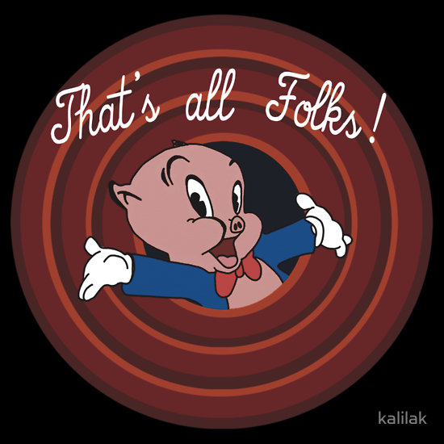

That’s all for now, look for the next “DID YOU KNOW”!

